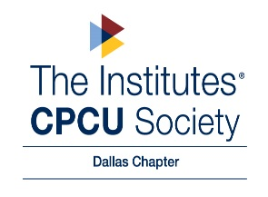
Volunteer Recognition Award
“Serving With a Purpose”

Purpose
The Dallas Chapter Volunteer Recognition Award was created to recognize the outstanding contributions made by chapter volunteers.

Criteria (meeting all criteria is not required for the recognition award)
- The volunteer displayed consistent attendance on committee calls and/or chapter luncheons.
- The volunteer has positively impacted the committee by actively volunteering in that particular month(s).
- The volunteer has demonstrated exceptional commitment, service, creativity, cooperation, and/or leadership.
- The volunteer has provided feedback and/or has been involved in committee work both during and outside of committee meetings.
- The volunteer recruits, guides, and inspires new volunteers.

Note: All chapter volunteers, except for Board Members, are eligible for the recognition award.

Process
• Board Members will collectively choose Volunteer Recognition candidates for selection (via phone, email, or in person) and determine which volunteer should receive the recognition award for the upcoming chapter luncheon.
• Board Members will describe how the actions of the volunteer have impacted their committee or chapter, and how the candidate has contributed to the chapter’s goals.
• Volunteers are eligible to receive this award only once per calendar year.
• In order to streamline the process the volunteer of the month will be selected at the board meeting prior to the following luncheon. Example: during the February board meeting, the board members will agree on the volunteer to recognize at the March luncheon.
• Volunteer(s) receiving recognition will be contacted prior to the luncheon date in which they are receiving the award to plan attendance.

Recognition
• The selected volunteer’s name, photo, and highlighted contributions will be published on the Dallas Chapter’s website until the next scheduled luncheon & social media sites: Facebook | Twitter | LinkedIn | Instagram
• A Volunteer of the Month certificate and $25 Amazon gift card will be presented to the chosen honoree at the CPCU luncheon by the chapter president.

